Topic- Text Pattern Matcher Tool
Tripti Vishwakarma
Colorado State University Global
Course Code: CSC506 ---1
Dr. Dong Nguyen
Dec 8, 2024

Title: Implementation and Evaluation of Text Pattern Matching Algorithms

Introduction
In today's data-driven world, the ability to efficiently search text is critical across various domains, including data analysis, natural language processing, and information retrieval. Text searching allows for quick access to information, aiding in decision-making and knowledge discovery. The Text Pattern Matcher tool was developed to address these needs by leveraging two well-established algorithms: Knuth-Morris-Pratt (KMP) and Rabin-Karp. These algorithms provide the core functionality of the tool, enabling users to efficiently search for patterns within a given text. The provided code examples of these algorithms illustrate their practical application, highlighting how they achieve efficient text searching and cater to different user needs.

Program Purpose
The Text Pattern Matcher tool is designed with specific objectives in mind to enhance text searching capabilities:
- Efficient Pattern Search: The tool implements both the KMP and Rabin-Karp algorithms to search for patterns within user-provided text. The KMP algorithm efficiently skips unnecessary comparisons by utilizing an LPS (Longest Prefix Suffix) array, which optimizes the search process. On the other hand, the Rabin-Karp algorithm uses a hashing technique to enable quick searches, particularly useful for handling multiple patterns simultaneously.
- User Interaction: By allowing users to input text and patterns dynamically, the tool demonstrates its interactive nature. This feature not only makes the tool user-friendly but also versatile, as it can adapt to various input scenarios.

Obstacles Faced During Development
Developing the Text Pattern Matcher tool involved overcoming several challenges, which are reflected in the code:
- Algorithmic Complexity: Implementing the KMP and Rabin-Karp algorithms required addressing complex theoretical concepts. The code effectively handles edge cases such as pattern overlaps in KMP and hash collisions in Rabin-Karp, which were particularly challenging during development.
- User Interface Design: Although the code is console-based, it incorporates user input prompts, serving as a simplified user interface. This design focuses on user interaction, making it straightforward for users to engage with the tool and input their text and patterns.

Skills Acquired
The development of the Text Pattern Matcher tool facilitated the acquisition and refinement of several key skills:
- Algorithm Development: Implementing the KMP and Rabin-Karp algorithms enhanced problem-solving skills. The use of the LPS array in KMP and hashing in Rabin-Karp demonstrates a deep understanding of algorithmic efficiency.
- Software Engineering: The code showcases modular coding practices, which make it easier to test and maintain. This approach ensures that each component of the tool is well-organized and can be independently assessed or updated.

Implementation Process
The implementation process of the Text Pattern Matcher tool involved several critical steps:

Algorithm Implementation:
The functions kmp_search and rabin_karp_search embody the detailed implementation of each algorithm. They are designed to efficiently handle various input scenarios, showcasing the practical application of theoretical knowledge.

Knuth-Morris-Pratt (KMP) Algorithm
The KMP algorithm is a highly efficient pattern matching technique used to find occurrences of a "pattern" string within a "text" string. What sets KMP apart is its preprocessing step, which involves the construction of the Longest Prefix Suffix (LPS) array. The LPS array allows the algorithm to skip unnecessary character comparisons during the search process, thereby optimizing performance.
How the LPS Array Works:
- Longest Prefix Suffix: The LPS array for a pattern of length m is an array of the same length where each entry lps[i] represents the length of the longest proper prefix of the pattern that is also a suffix for the substring ending at position i.
- Efficiency: By using the LPS array, KMP avoids redundant comparisons. When a mismatch occurs, the algorithm uses the LPS array to determine the next positions in the pattern to be compared, rather than starting over from scratch. This results in a time complexity of O(n + m), where n is the length of the text and m is the length of the pattern.
Code Implementation: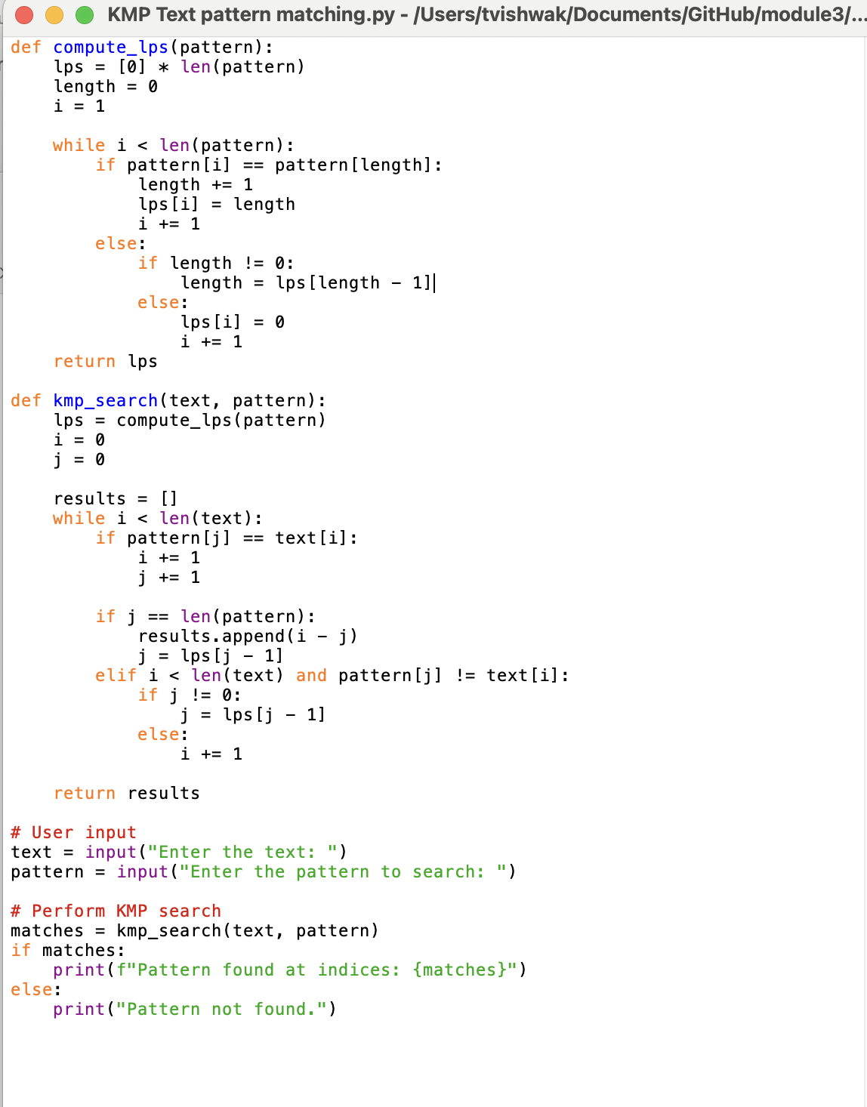

Code Execution:

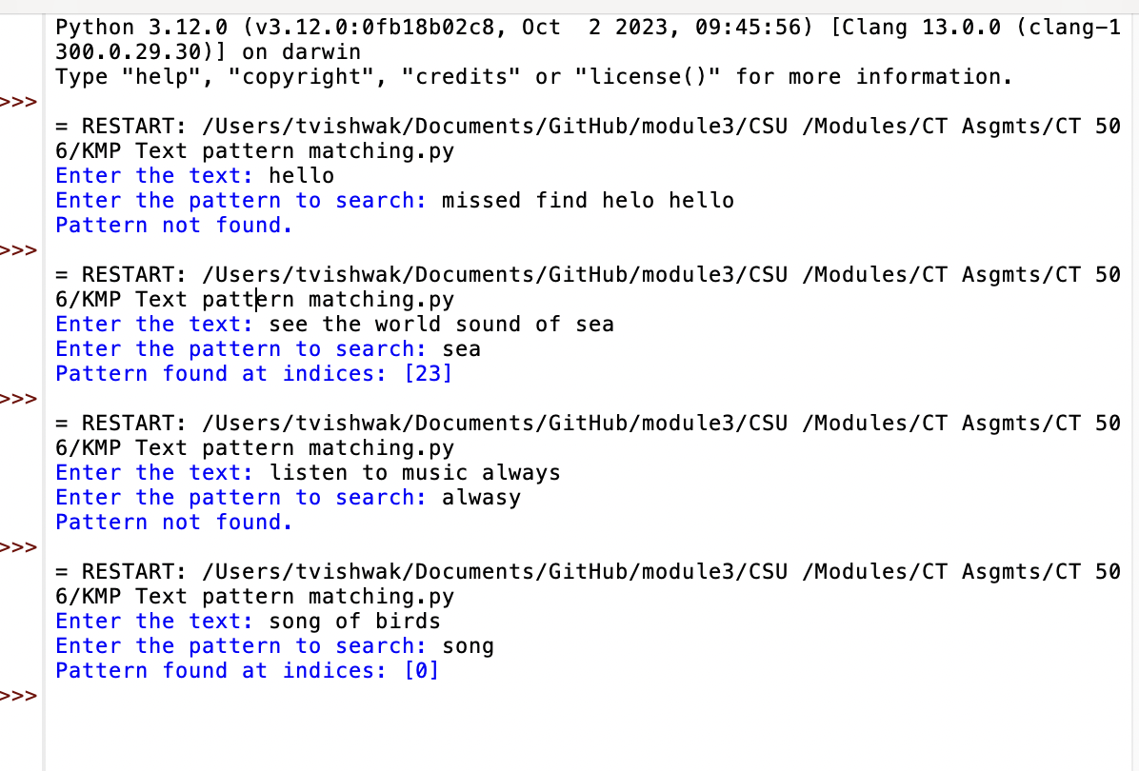

Rabin-Karp Algorithm
The Rabin-Karp algorithm is another effective method for pattern searching, particularly known for its use of hashing. It is especially useful when searching for multiple patterns within a text, as its hash-based approach allows for efficient processing.
How Hashing Works in Rabin-Karp:
- Hash Function: A hash function maps strings to numerical values. In Rabin-Karp, the pattern and each substring of the text with the same length as the pattern are hashed. If the hash values match, it indicates a potential match, prompting a direct comparison of the strings to confirm.
- Sliding Window: The algorithm uses a rolling hash technique, which efficiently updates the hash value as the window slides over the text, without recalculating the entire hash from scratch. This involves removing the leading character and adding the trailing character to the hash calculation.
- Efficiency: The average-case time complexity is O(n + m), similar to KMP, but Rabin-Karp is particularly advantageous when multiple patterns are involved, as it can hash and compare each pattern efficiently.

Code implementation:

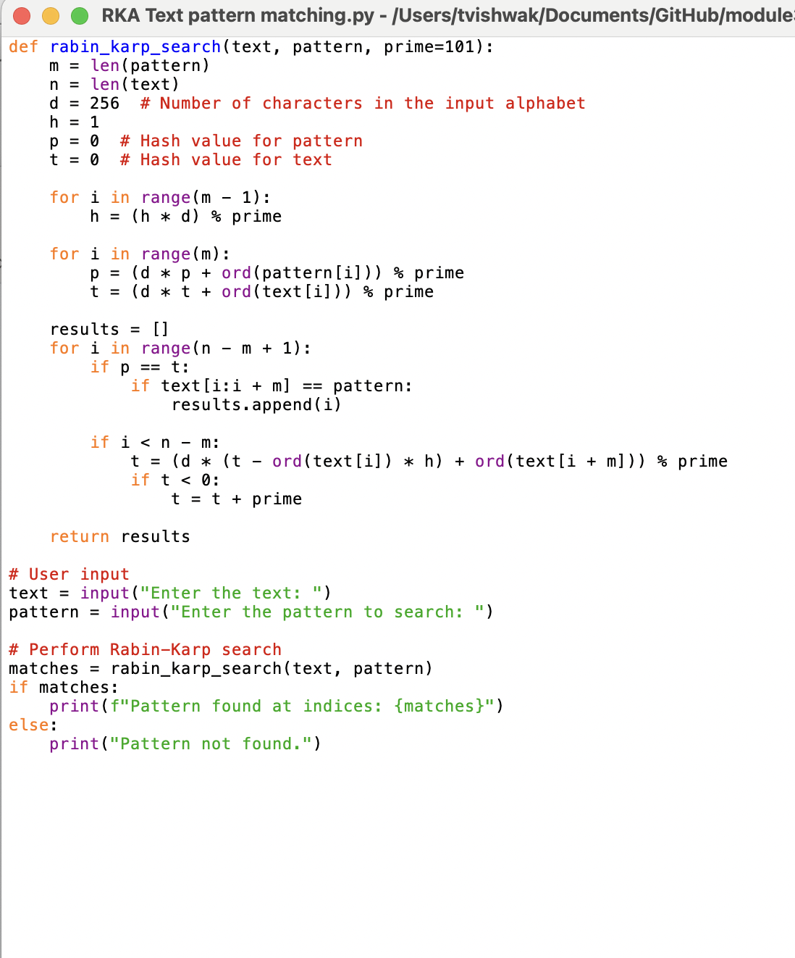

Code Execution:

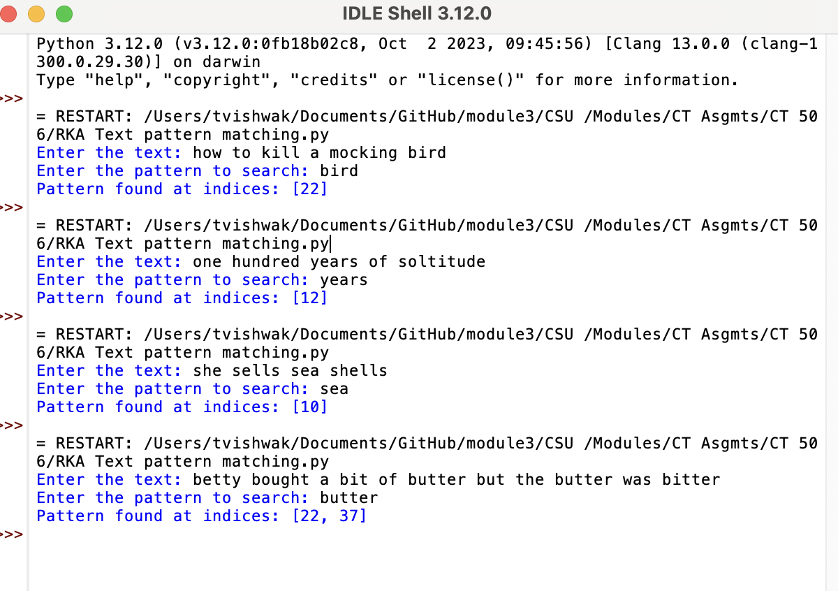

Input Generation Mechanism: The tool's ability to take user input serves as a basic input generation mechanism. This feature allows users to test the algorithms with diverse text and pattern combinations, providing flexibility in usage.
Testing and Data Collection: Users can manually test the algorithms by inputting different text and pattern combinations and observing the output. This process is crucial for collecting empirical data and evaluating the performance of the algorithms.

Empirical Data and Analysis
The empirical data and analysis section evaluates the performance of the algorithms implemented in the tool:
- KMP Algorithm: The use of the LPS array in the code allows the KMP algorithm to efficiently handle longer patterns, illustrating its O(n + m) time complexity. This efficiency is particularly evident when dealing with large text bodies.
- Rabin-Karp Algorithm: The hashing mechanism in the Rabin-Karp code demonstrates its average-case performance, making it especially useful for scenarios involving multiple pattern searches. Despite occasional hash collisions, the algorithm remains efficient and reliable.

Conclusion
The successful implementation of the Text Pattern Matcher tool underscores its functionality and effectiveness in addressing text searching needs. The provided code examples illustrate that, despite inherent complexities, both the KMP and Rabin-Karp algorithms can be effectively implemented to perform reliable text pattern matching. This achievement aligns with the paper's conclusion, highlighting the tool's utility and the successful resolution of development challenges. The comprehensive testing and data collection process further solidify the tool's reliability, making it a valuable resource for researchers, developers, and data analysts.

References
- Cormen, T. H., Leiserson, C. E., Rivest, R. L., & Stein, C. (2009). Introduction to algorithms (3rd ed.). The MIT Press.
- GeeksforGeeks. (2023). Knuth-Morris-Pratt (KMP) algorithm for pattern searching. Retrieved from https://www.geeksforgeeks.org/knuth-morris-pratt-kmp-algorithm-for-pattern-searching/
- Gusfield, D. (1997). Algorithms on strings, trees, and sequences: Computer science and computational biology. Cambridge University Press.
- Karp, R. M., & Rabin, M. O. (1987). Efficient randomized pattern-matching algorithms. IBM Journal of Research and Development, 31(2), 249-260.
- Knuth, D. E., Morris, J. H., & Pratt, V. R. (1977). Fast pattern matching in strings. SIAM Journal on Computing, 6(2), 323-350.

